**Guided Capstone Report: Recommendations for Big Mountain Resort**

Big Mountain Resort currently charges $81 for an adult weekend ski lift ticket, but based on the models it should charge $95.87. The important features used in the model include: vertical drop, snow making, total chairs, fast quads, runs, longest run, trams and skiable terrain.

Potential scenarios for cutting costs or increasing revenue from ticket prices:

1. Permanently close down up to 10 of the least used runs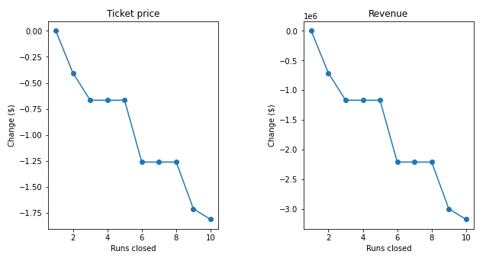

This scenario would reduce support for ticket price and lead to a drop in revenue.

1. Add a run, increasing the vertical drop by 150 feet and install an additional chair lift.

This would increase support for ticket price by $1.99, an increase of $3.5 million in revenue for the season.

1. Add a run (increasing the vertical drop by 150 feet), install an additional chair lift, and add 2 acres of snow making cover.

This yields the same results at scenario 2, with increase in support for ticket price by $1.99, and increase revenue for the season by $3.5 million. Thus, a small increase in snow makes no difference.

1. Increase the longest run by 0.2 mile (to boast 3.5 miles length) and require additional snow making coverage of 4 acres.

This would not yield any change in price or revenue.

Based on these options, **scenario 2 presents the greatest revenue increase**.